
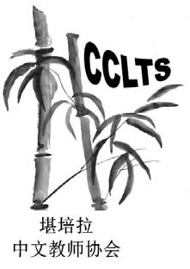

Chinese Language Teachers Association of ACT (CLTAACT) Inc ABN 51 358 227 533

2018 24th CLTFA National Conference

The 24th National Conference of the Chinese Language Teachers Federation Australia (CLTFA) will be held at the Canberra Grammar School, Canberra on Saturday 7 and Sunday 8 July 2018.
This conference has played an important role for Chinese language educators from primary, secondary and tertiary schools since it was initiated in 1994. It provides great opportunities for educators, including community school teachers, to share knowledge and ideas, to build up network connection and to access most recent research results in linguistics and education.
The theme of this conference is Chinese Acquisition: Theory and Practice.
The keynote speakers are Professor Yang Zhao, Beijing University, China, Professor Yutaka Furukawa, Osaka University, Japan and Professor Richard Rigby, Australian National University.
It is our plan to organise some 40 workshop presentations during the conference and hence we are urgently calling for presenters to register now.
With more than 300 prospective participants from all over the world, it is also a great opportunity for our sponsors to provide their support to Chinese language teaching and learning and to promote their products.
Please register for the conference using the links below:
Participants registration form https://goo.gl/forms/hxOBfYV7kdzGHUNs1 Presenters registration form https://goo.gl/forms/5RD937DhGnMve1um1 Sponsorship registration form https://goo.gl/forms/HDYKZrVUX4iy8ULJ2
CLTAACT thank you for your ongoing support and we are looking forward to meeting in Canberra.
If you have any enquiry, please feel free to contact us. Email to: CLFTAConferenceCanberra2018@trilong.com.au

