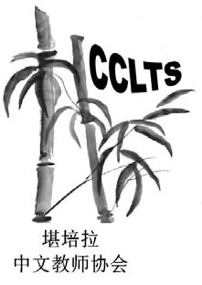Chinese Language Teachers Association of ACT (CLTAACT) Inc ABN 51 358 227 533
2018 24th CLTFA National Conference (7-8 July 2018)

The CLTAACT Organising Committee invites proposals for papers and workshops presentations related to the conference theme:
Chinese Acquisition: Theory and Practice

Keynote Speakers:
Professor Yang Zhao, Beijing University China
Professor Yutaka Furukawa (古川裕), Osaka University Japan
Professor Richard Rigby, Australian National University Australia

Accepted papers and workshops will form the major part of the conference program and will be scheduled in approximately 50-minute timeslots.
- Submission of the abstract of a workshop presentation should be in English (and Chinese if possible) limiting from 100 to 150 words
- The submission deadline is Friday 30th April 2018.
You are strongly encouraged to submit before the required submission deadline. Quality submissions will be accepted once reviewed.
Please Note:
All documents must be saved as word documents file and all photos must be in jpg format
Please complete the submission form and email it with a recent photo to: CLFTAConferenceCanberra2018@trilong.com.au
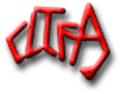
CHINESE LANGUAGE TEACHERS’ FEDERATION OF AUSTRALIA (Inc)
24TH CLTFA NATIONAL CONFERENCE
Chinese Acquisition: Theory and Practice
Please fill out the Submission Form and email it with your recent photo to: CLFTAConferenceCanberra2018@trilong.com.au
Title | First Name | Surname
Workplace

Mobile Contact
Topic of the Presentation/Workshop
(Topic should be relevant to the conference theme and current concerns of the profession. Maximum length is 12 words)
Outline of Submission
(Outline should be in Point form and no more than 200 words)

A Brief Self- Introduction (about 100 words)

Are You Willing to Repeat Your Presentation/Workshop if Required

